

“Love the nature! Feel the true happiness!”

 

**Smart Garden: Gardening and Landscaping Services**

**A Mobile Application**

**Introduction:**

Garden care business is bringing home the beauty of mother nature. With the massive booming of mobile application era alongside the dramatic feet of core marketing strategies, it is an excellent new business opportunity to introduce the SMART GARDEN. It is a company that provides gardening and landscaping services to homes, offices, stadiums, festive and occasional celebrations, etc. As a start-up, the service is provided only through the mobile application called the ‘Smart Garden’.

**Customer Need:**

In life, people are running on extremely tight schedules. They earn enough but are devoid of their leisure time to grow the beautiful garden that they wish for. They have several gardening needs such as sprucing up the landscape for the season, needing a hand in planting trees and shrubs, trimming over-grown gardens and creating the look and feel of their desirable theme.

Besides pleasure, sometimes people have unavoidable need for lush green beauty and medicinal benefits to elevate health and state of mind, high quality sodding to reduce erosion and heat, and have good oxygen supply, creating play area, general weeding, turf laying around the house and in stadiums, etc.

Also, aesthetics of the terrains outside office accommodations is being given huge importance these days. Companies make sure to have the best and unique working atmosphere inside and outside of an office accommodation. What we see impacts our state of mind. It is proven that a beautiful work location psychologically makes the employees more attached with office.

It is always true that either there is no time for gardening or the garden is so vast and unmanageable. There is an ultimate need for a vendor to provide a package of gardening services at the finger touch of a mobile application.

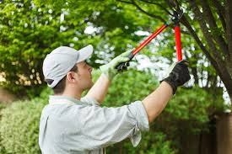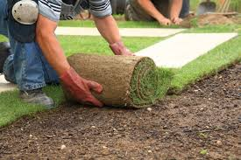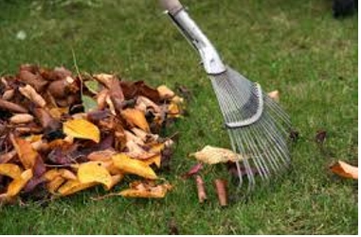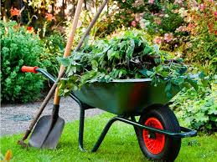

**Features of Smart Garden:**

The products and the services offered by Smart Garden are exotic garden themes, floral colour suggestions, disease specific plants, grafting of hybrid plants, organic food plants, interior decoration plants, bordering plants, soil based suggestions, heavy duty machines for relocating and rooting giant trees, season special gardens, geologically unique gardens, hanging gardens.

For every newly registered address, we are introducing 50% discount on the first purchase of a product or a service. For annual subscriptions, the last month service is free. Users can collect points on booking any service or buying any plants, redeem those points and subscribe to monthly or biweekly garden or large terrain clean up and manuring service. They can both buy and sell plants using this mobile app. The customers can chat with the other customers sharing their gardening suggestions. The mobile app shall bring the interest group together. Whilst a user orders a plant or a manure, another user can pick-up, deliver if they happen to cross the nursery and go near the original customer’s place, and earn through it.

**Need For New Mobile Application:**

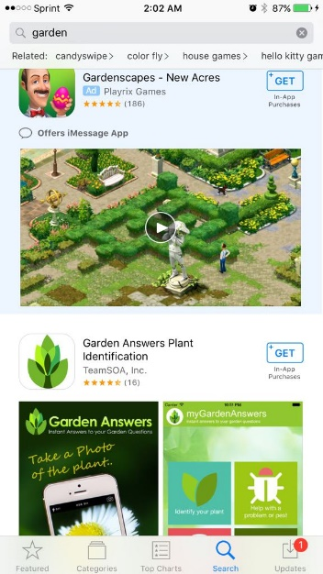 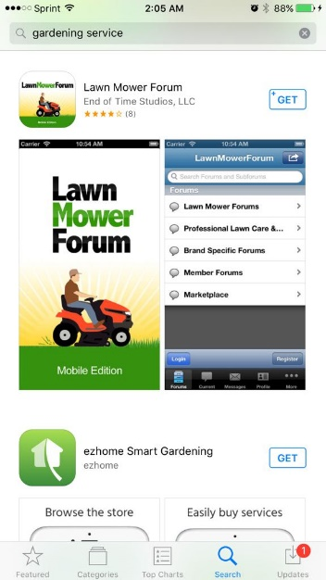  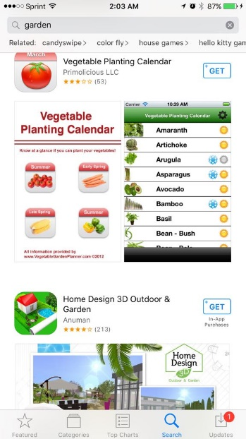

When searched for ‘garden’ and ‘gardening service’ on the Apple App-store, the results were gardening game applications, gardening calendar applications and a few lawn moving service providers. Smart Garden is the first of its kind, delivering a wholesome package of gardening service at a finger touch, catering the needs of all kinds of customers. All aspects of gardening are present in the mobile application in order to make the Smart Garden as the ultimate choice for the customers.

As the Smart Garden team, we believe that we should have the in-depth and wide spread plunge into the market at the time of launch itself. We are in the urge to make a powerful entry, not waiting for a gradual growth over years. There is an irresistible need to come up with the most sophisticated marketing strategies in positioning, branding and communication of the Smart Garden. The prestige of the high impact launch shall then be driven through golden years by delivering excellence. Also we need to formulate recommendations for customer acquisition and loyalty building. With a matured customer and competitor sense, if proper target marketing and pricing is carried out, Smart Garden will be a sure success.

**Customer Segmentation:**

**Based on the Liking Towards Gardening:**

**Based on the Liking Towards Gardening Mobile Application:**

**Competitor Analysis:**

**Top Companies Competing Portions Of Our Service:**

**Lawn Service Providers:** Ecology Center

**Pest Controllers:** BerrettPestControllers

**Fertilizing Agencies:** Green Lawn Fertilizing

**Customer Reach Methods Competing Our Mobile Application Idea:**

**Websites:** www.calloways.com

**Local Nurseries Across US: Altman Plants (**$125 million annual sales**)**

**On-Call Services: LawnTech**

For every region of establishment, the companies that appear first on the search engine almost win the race. In all forms of media, Smart Garden should be the most projected using intensive marketing analytics.

**Limitations of our Competitor:**

They don’t provide wholesome service. Our competitors have only the buyer –seller interaction. No customer – customer interaction.

No service provider lavishly gives offers as Smart Garden will give. Smart Garden is keen on customer delight factor.

**SWOT Analysis:**

**Strength:**

Smart Garden is going to be the unconditionally reliable destination for the customers like how Amazon is the ultimate destination for online shopping.

On the Smart Garden platform, the customer can connect with the other customers as well forming a like-interest group.

**Weakness:**

Being a new product, Smart Garden has the burden of beating the early players of the gardening industry.

Smart garden cannot include people with lot of leisure time into their customer base.

**Opportunity:**

Whilst the competitor operates on websites and shops, Smart Garden is the most powerful entrant in the void space mobile application market.

**Threat:**

Customers should feel comfortable with the use of mobile application, specially the countryside families and organizations

As long as the customer’s life is busy, Smart Garden can do gardening for them.

**Potential Market:**

Census data is always available free of cost. It is the best source of information about our customers for any market analyst.

|  | **Any**  **cell phone** | **Smartphone** | **Cell phone, but not smart phone** |
| --- | --- | --- | --- |
| **Total** | 95% | 77% | 18% |
| **Men** | 96% | 78% | 18% |
| **Women** | 94% | 75% | 19% |
| **Ages 18-29** | 100% | 92% | 8% |
| **30-49** | 99% | 88% | 11% |
| **Some college** | 96% | 80% | 16% |
| **College graduate** | 97% | 89% | 8% |
| **Less than $30,000** | 92% | 64% | 29% |
| **$30,000-$49,999** | 95% | 74% | 21% |
| **Urban** | 95% | 77% | 17% |
| **Suburban** | 96% | 79% | 16% |
| **Rural** | 94% | 67% | 27% |

**The potential market cluster comprises of:**

**Outdoor Sports Clubs**

**Corporate Offices**

**Community garden growers**

**Home Food Growers**

**Young Female Smartphone Users**

**Statistical Talks:**

* **35% of U.S. households in America, are growing food at home or in a community garden**
* **Largest increases in participation seen among younger households - up 63% since 2008**
* **2 million more household community gardens anticipated**

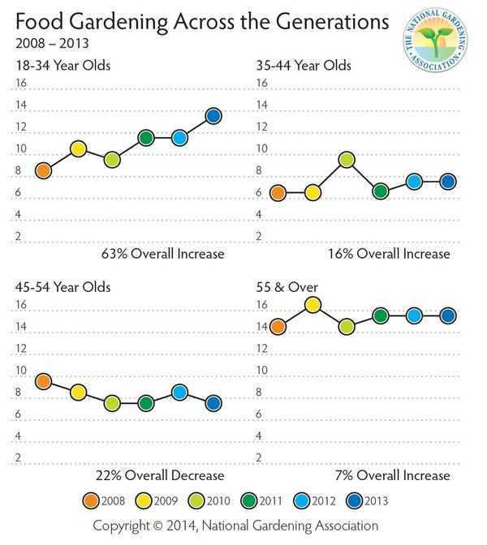

**Pricing Sheet of Products and Services:**

**Smart Garden Products:**

Exotic garden themes (as a package) = $ 30 per 100 sq.ft

Floral colours (Avg. price – rate varies with the species) = $ 3 per plant sampling

Disease specific plants (Avg.Price – rare species are priced high) = $ 7 per plant sampling

Grafting of hybrid plants (User customization plus biological feasibility) = $ 9 per plant sampling

Organic food plants = $ 3 per plant sampling

Interior decoration plants = $ 2 per plant sampling

Bordering plants = $5 per plant sampling

Turf Laying per 100 Sq.ft materials = $20

**Smart Garden Services:**

Planting (terrain specific) per 100 Sq.Ft = $1

Weeding per 100 Sq.ft = $2

Turf Laying charge per 100 Sq.ft = $10

Lanscaping (including huge tree relocations) per 100 Sq.ft = $5

**Revenue Model:**

**Revenue1** = Year1 Earnings – Year1 Expenses;

**Revenue2** = Year2 Earnings – Year2 Expenses;

**Lift in the Revenue = Revenue2 – Revenue1;**

**This Lift will indicate the Smart Garden’s establishment index and future prospects.**

**Year 1 Earnings:**

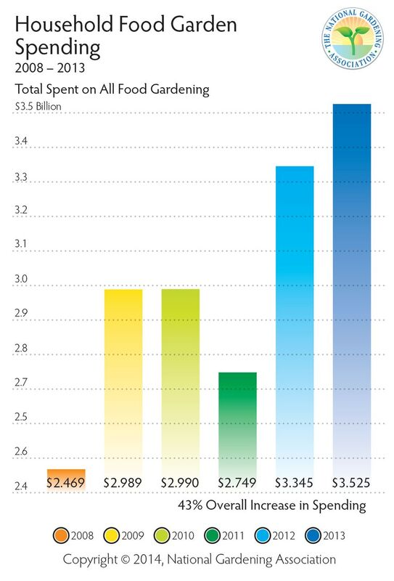

**Food Gardens (Most Essential):**

35% of U.S. household = 42 million households

Purchase of food crops and manures per household = $83.92

Annual Household spend = $3.525 Billion

Target the whole 35% of the households in year1. The non-respondents of year1 shall be given special importance in year2

Service charges per house hold (@once a month) = $8 per month

Household service charge per year = $96

Total Earnings through food gardens = $ 180 per household

**Ambience Gardens (indoor and outdoor)**

U.S. Households (annually) = $ 70 Million

Corporate Offices (annually) = $ 83 Million

Special Event Decorations (annually) = $ 89 Million

Total Annual Earnings = $ 242 Million

**Heavy- Duty Machinery Services:**

In sports grounds, private estates & government contracts,

Turf Laying Materials = $ 10 Million

Lawn Laying = $ 34 Million

Periodic Lawn Care = $ 60 Million

Landscaping = $ 25 Million

Pest Control and weeding = $ 50 Million

Machinery and Service Charge = $ 3 Million

Total Heavy- Duty Machinery earnings per annum = $ 182 Million

Total Year1 Earnings = $ 3.949 Billion

In order to capture the customer delight, Smart Garden Application is not hosting any third-party advertisements when the users use this application. It is an ad-free application.

**Year 1 Expenses**

Initial one time investment = $653 Million

**Excluding one time capital Investment:**

Organization Establishments in six major cities (Nurseries and Machineries) = $70 Million

Employee Salary = $100 Million

Product Shipping and Team Logistics = $ 50 Million

Promotions across all media = $ 40 Million

Total Process Cost = $ 260 Million

**Year 2 Earnings:**

Covering the Year1 10% non-Respondents as well in year 2, Smart Garden is eagerly anticipating 5% increase in the earnings

Earnings = ($3. 949 Billion *(5/100)) + $3. 949 Billion

= $ 4.147 Billion

**Year2 Expenses:**

Incurring additional promotional charges for target marketing = $25 Million

Actual Expenses similar to Year1 = $260 Million

Miscellaneous Expenses = 2 Million

Total Year 2 expenses = 287 Million

**Revenue1** = Year1 Earnings – Year1 Expenses;

= $3.949 Billion – $653 Million - 287 Million;

Profit = $3.009 Billion

**Revenue2** = Year2 Earnings – Year2 Expenses;

= $4.147 Billion-287Million;

= $ 3.86 Billion

**Lift in the Revenue = Revenue2 – Revenue1**

= $3.86 Billion - $3.009 Billion

= $851,000

This lift in the revenue indicates good future for Smart Garden.

**Promotions:**

1. Bringing Smart garden as the first search result in any search result
2. Direct Mailing (5.3% response rate - greater than other forms of promotions)
3. Refer a friend to get 10 % offer on the next gardening service
4. Conducting a marketing competition for graduate students for product promotions
5. Plants in each community with ‘Smart Garden’ hanging boards
6. Floral bouquet and promotional gift distribution





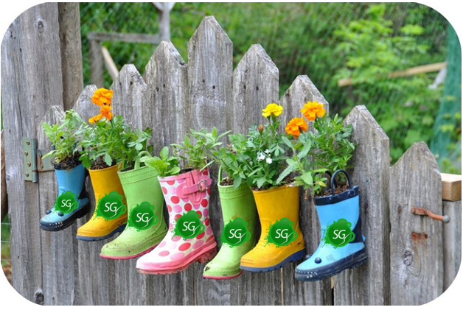

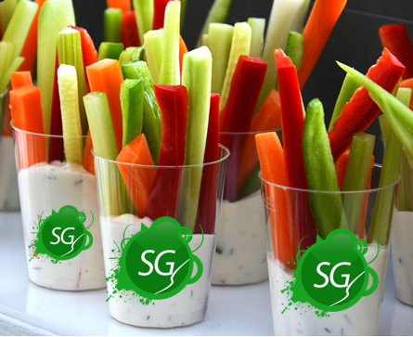



**Future Road Map:**

Expanding distribution centres in good geographical market sectors

Upgrading the mobile application to give monthly reminders and special offer notification